Willis Allstead

4/16/18

CS 219

HW9

1)

**- I’m trying to learn how to subtract two 64-bit integers in ARM assembly and save it to a memory location.**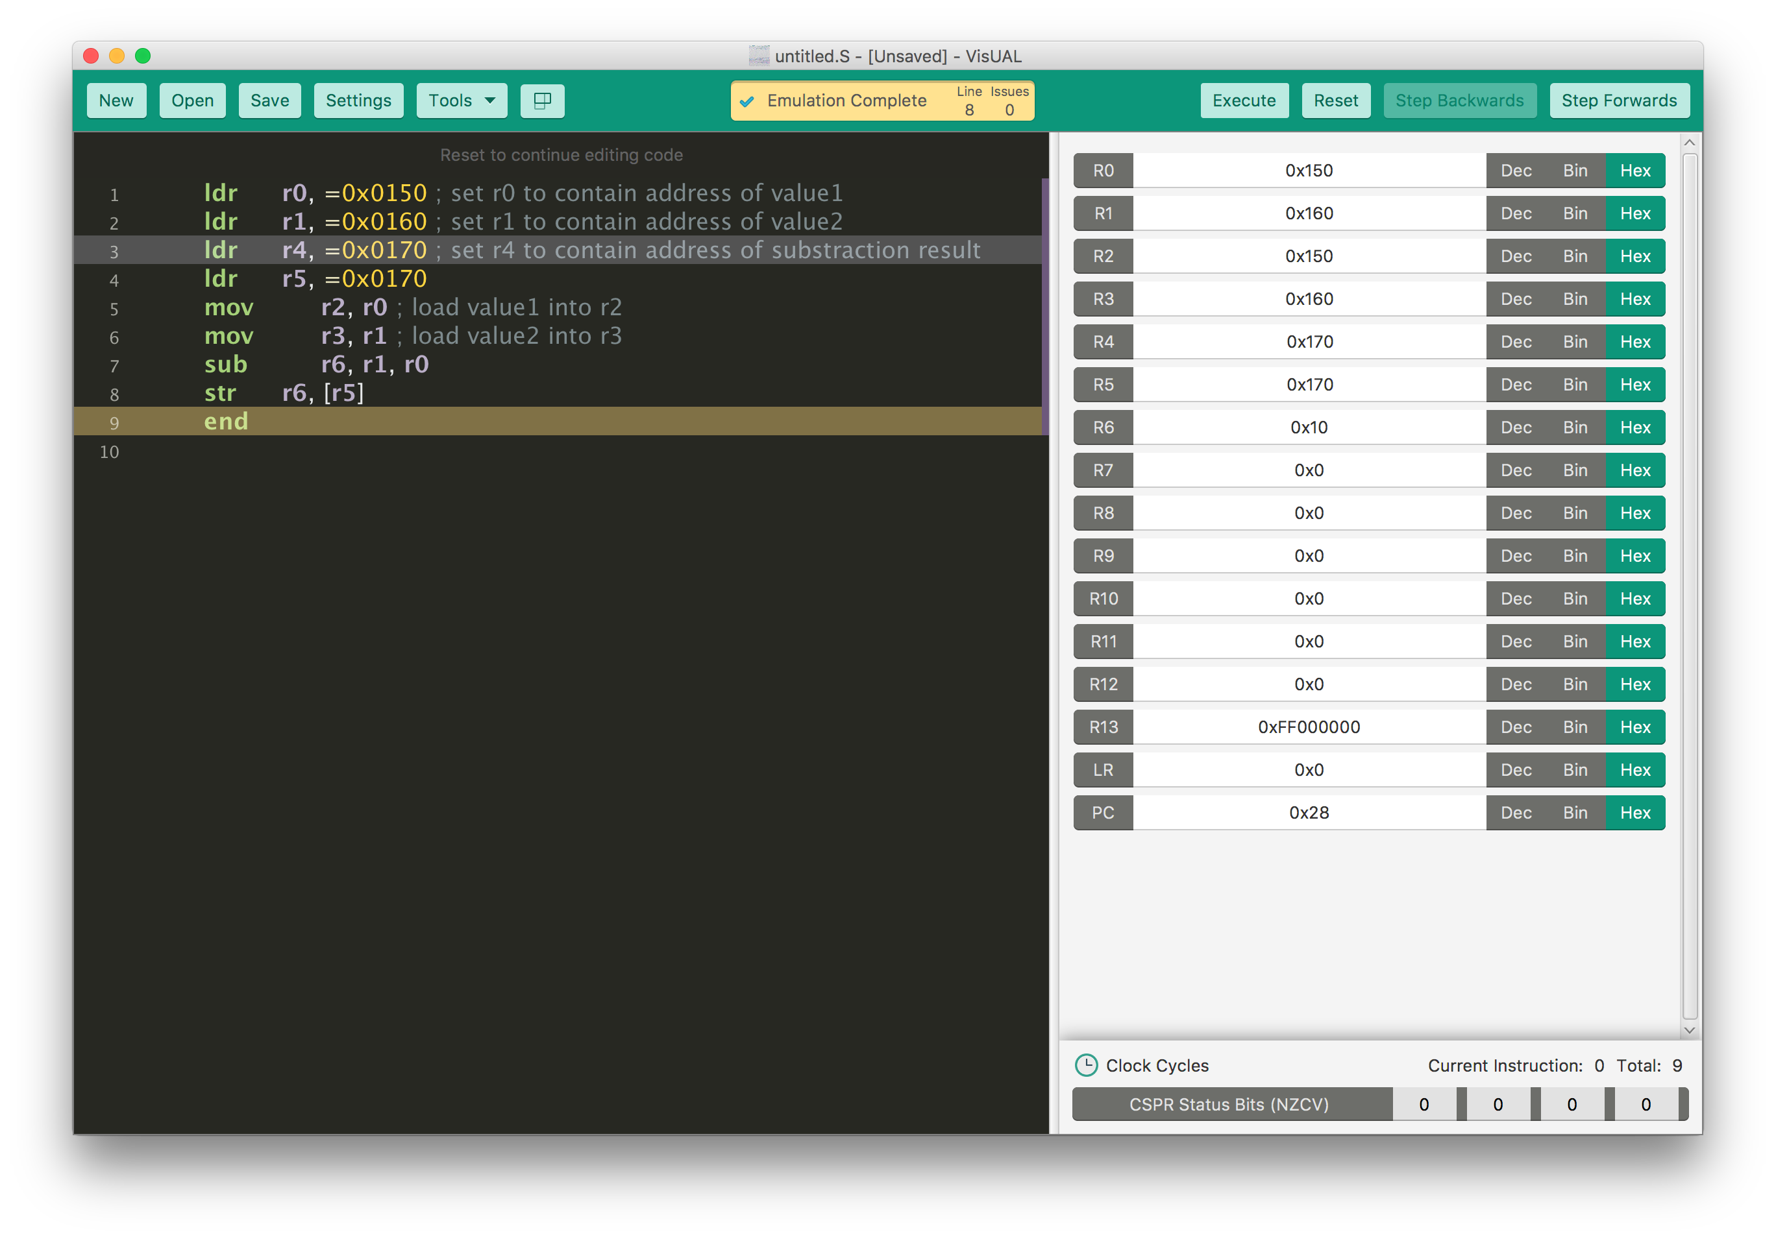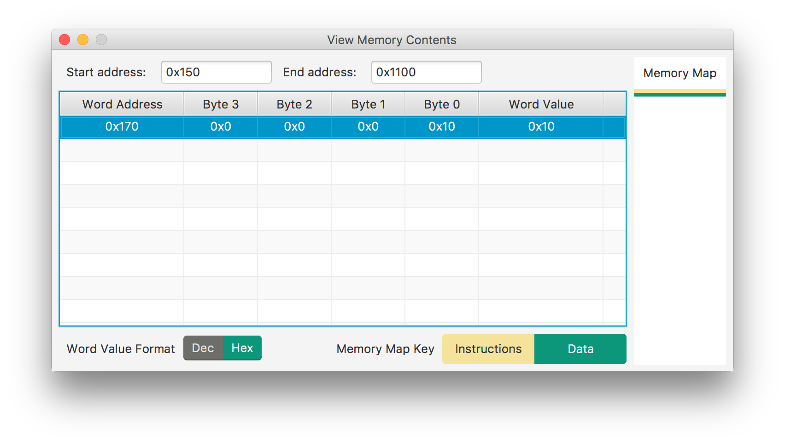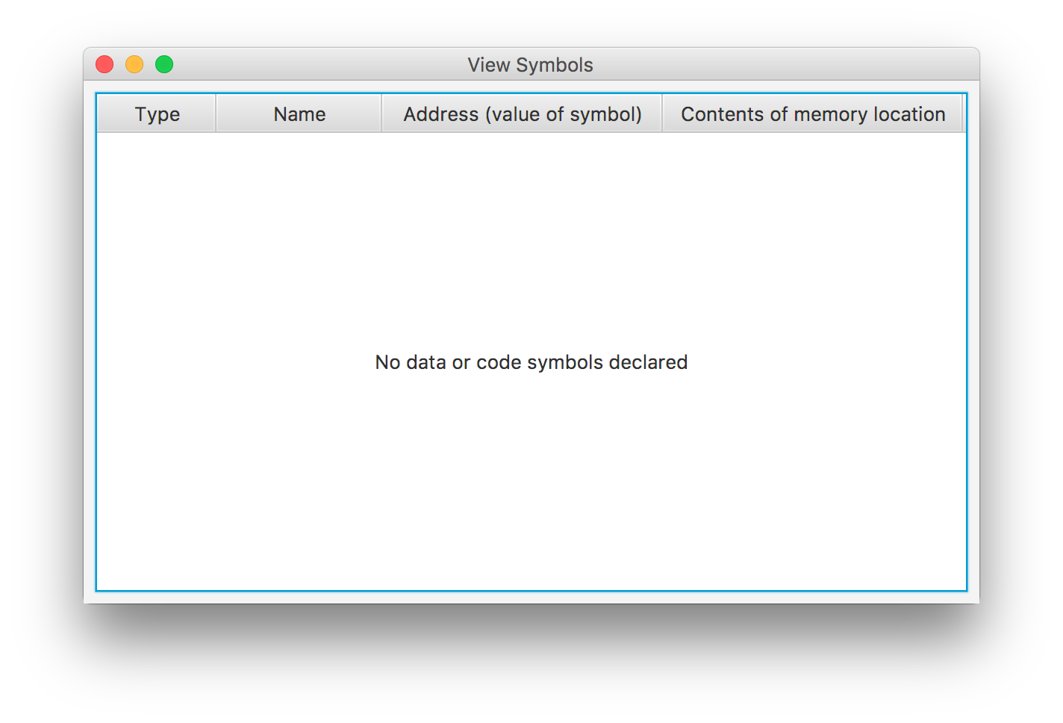

3)

**- I’m trying to learn how to compare two numbers in ARM assembly.**

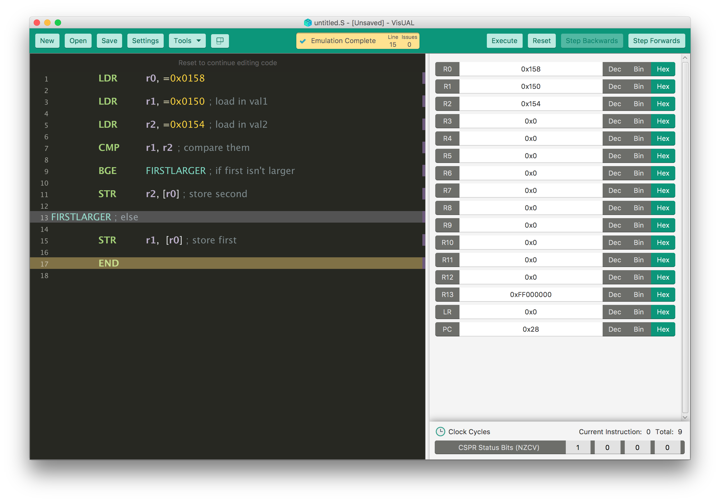

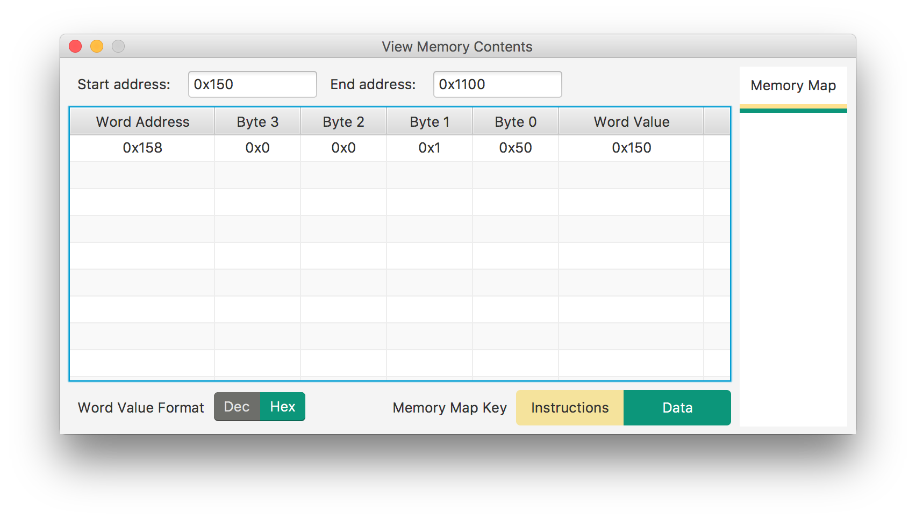

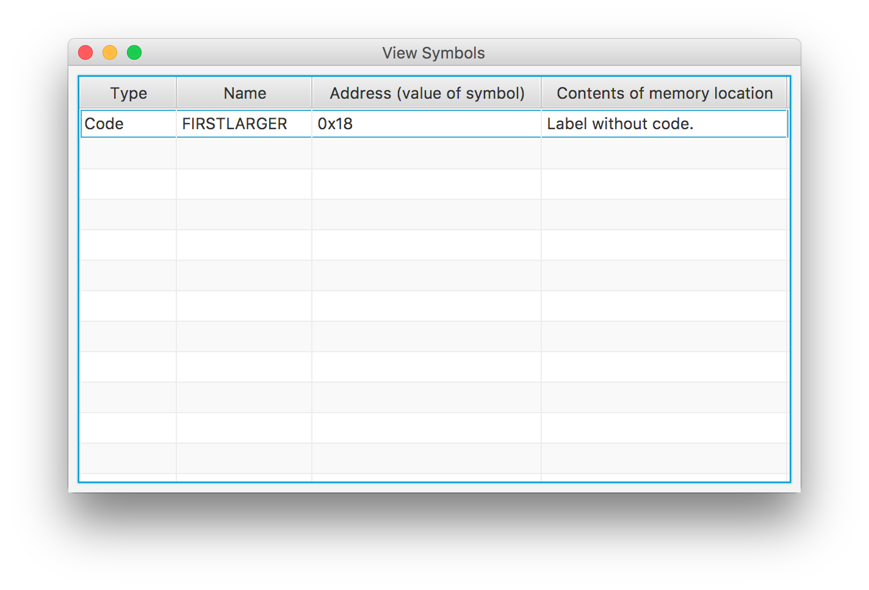

4)

**- I’m trying to learn how to logically left shift a number in ARM assembly and save it to a memory location**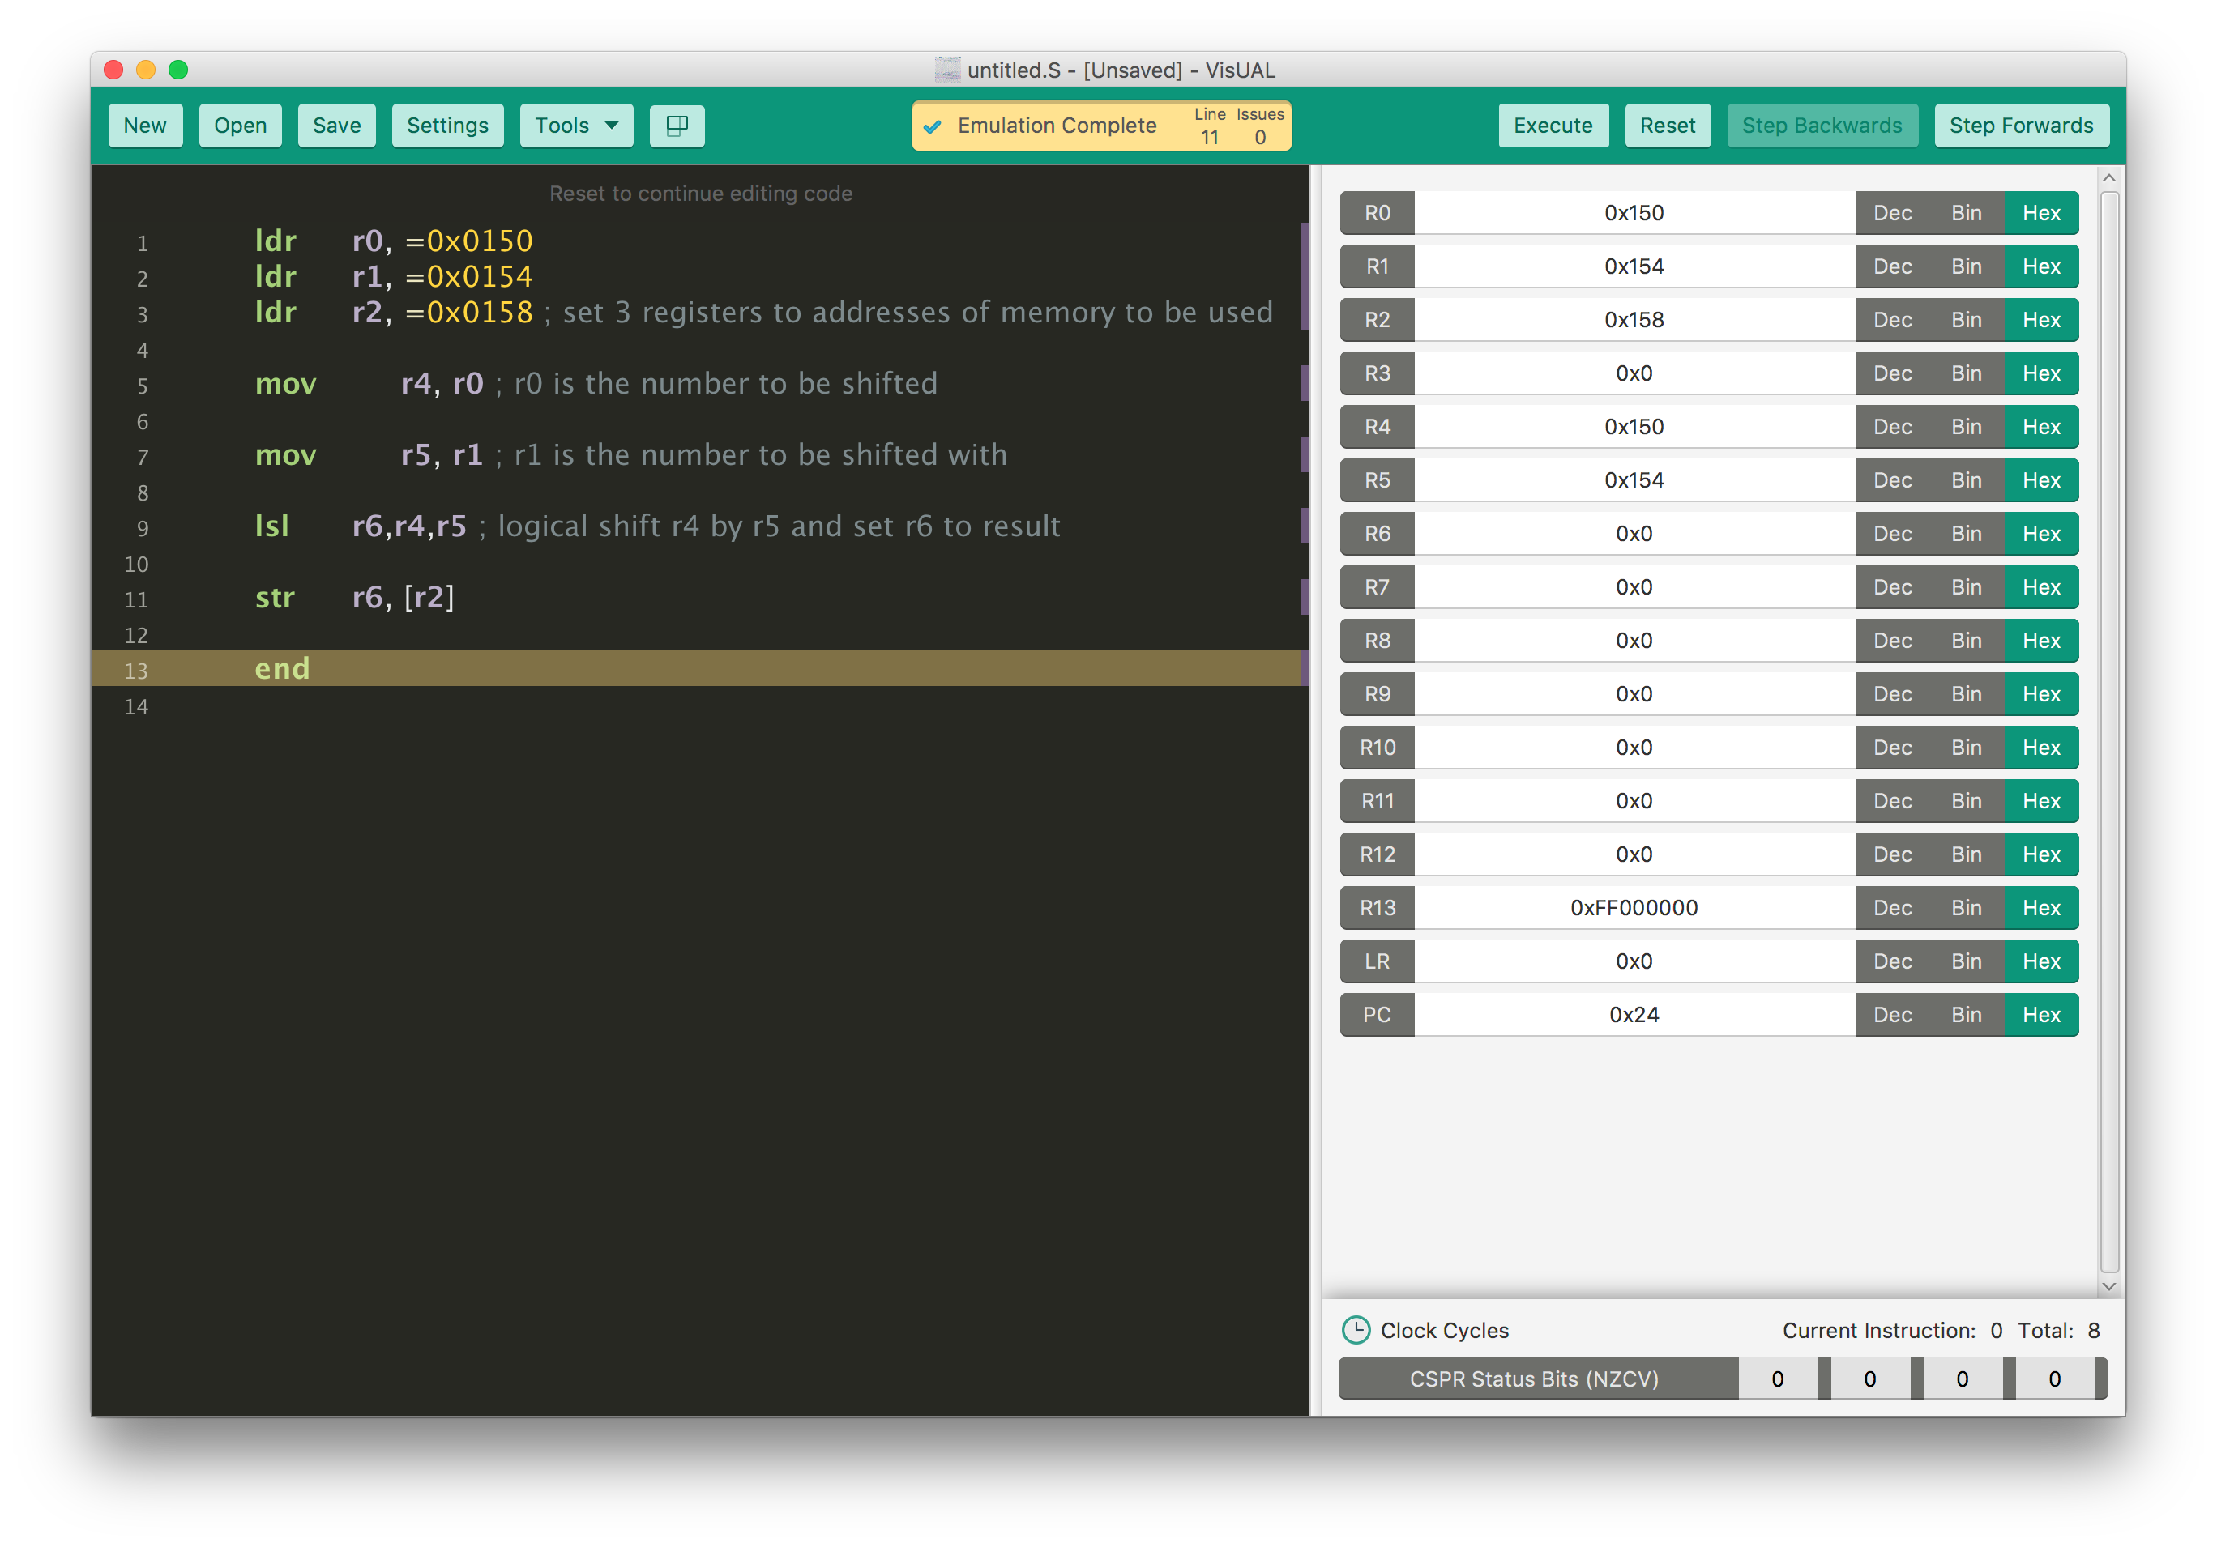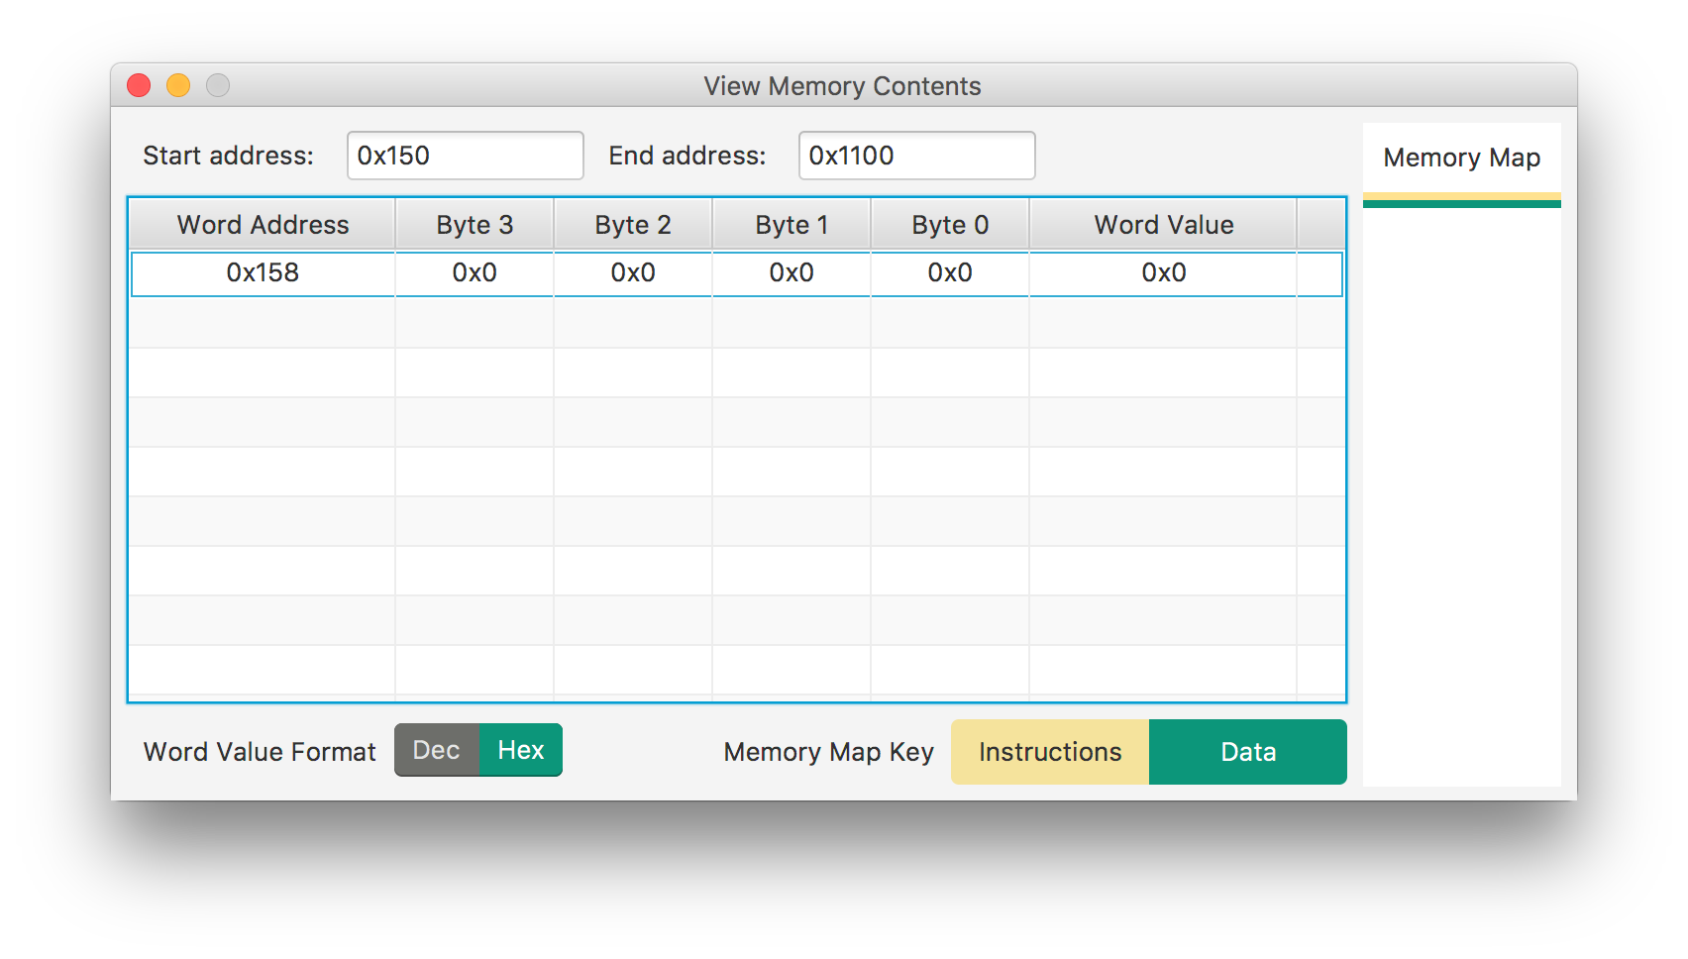

5)

**- I’m trying to learn how to find the largest 32-bit word in a list, and store the largest word in a memory location.**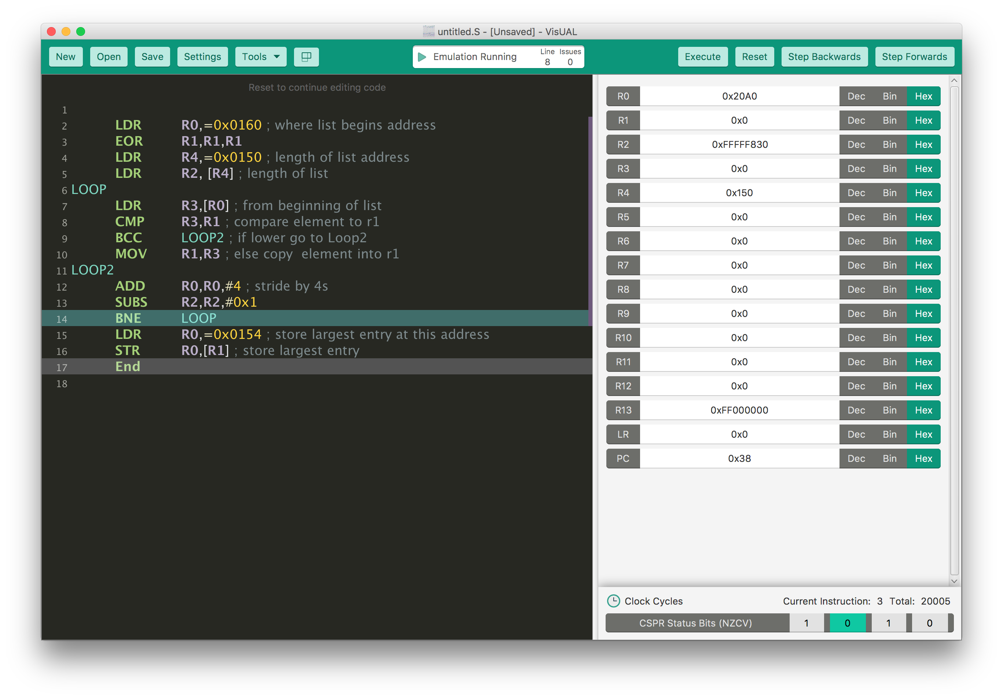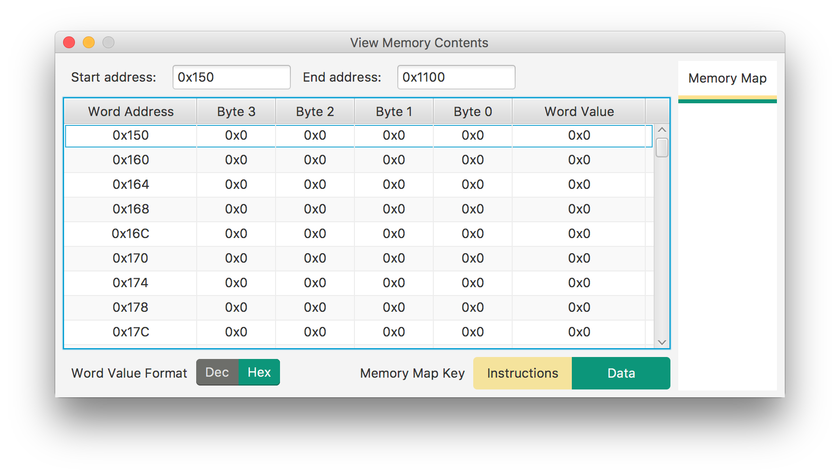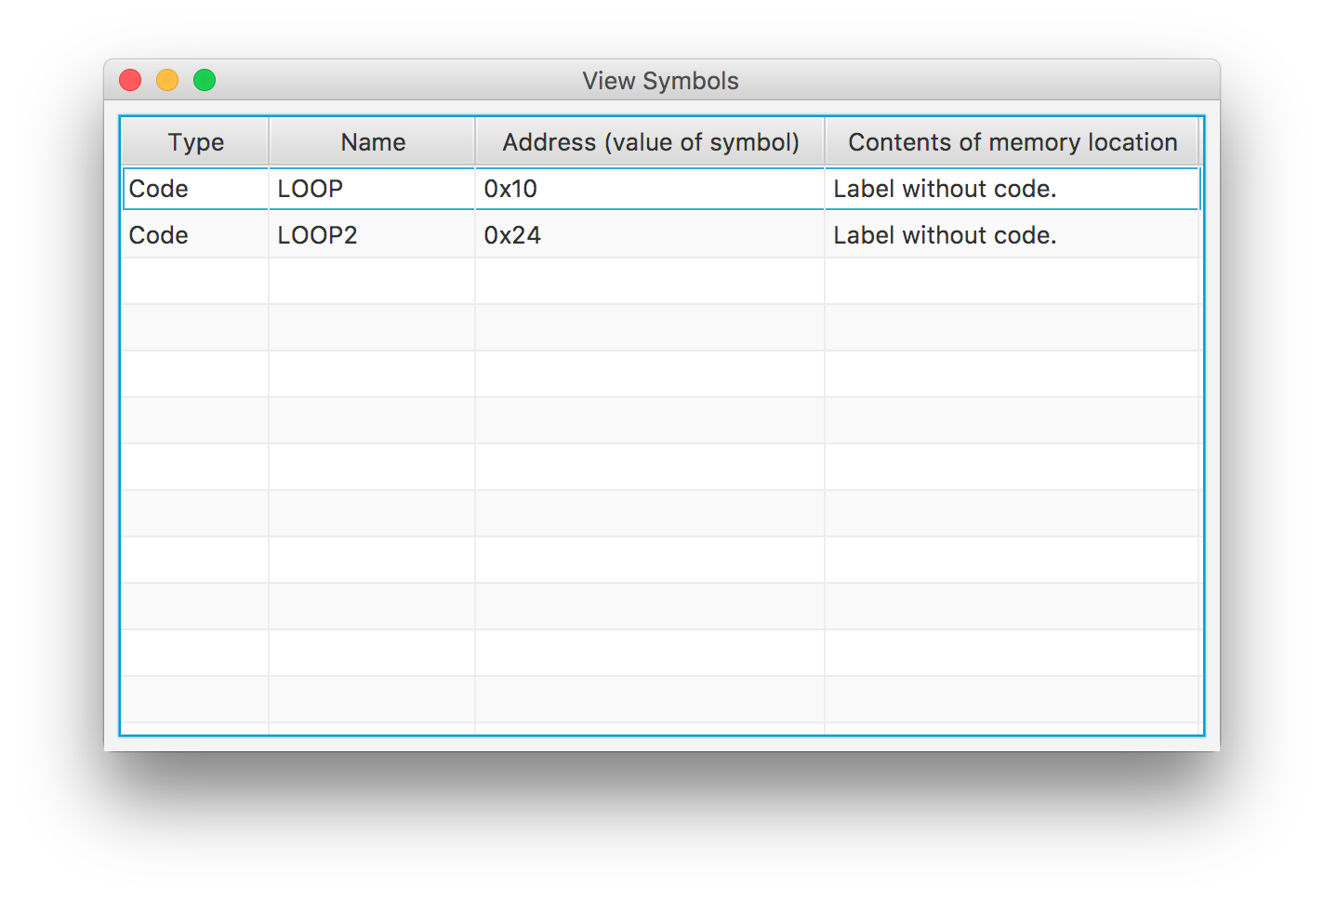

6)

**- I’m trying to learn how to scan a list of unsigned bytes to find the smallest and largest numbers in the list.**



